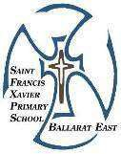
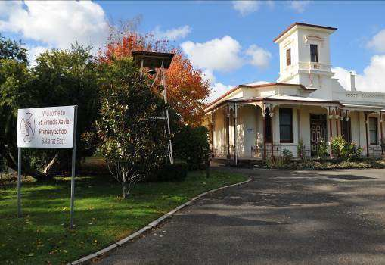
St. Francis Xavier Primary School BALLLARAT EAST Ltd.

REGISTERED SCHOOL NUMBER: 981

Enrolment Prospectus

Contents
Introduction 3
Our School Vision Mission and School Prayer 4
School Overview 5
History of Our School 7
Enrolment Process 8
Curriculum Overview 10
Student Wellbeing 12
Child Safety 13
Parental Involvement 15
School Finances 16
School Fees and Levies 17
General Information 18
Contact Details 19

Introduction

Principal's Welcome


We welcome you and your child to St Francis Xavier and hope the years spent here will be successful and enjoyable. Every child is unique. Every child is special, with needs, special interests and particular characteristics. Your child is important to us and we need to work together to help him/her to grow, learn and develop both as an individual and as a member of our school community.

Our school is a unique school that continues to offer challenge and excitement for our children. There is a confidence and vitality that is

reflected in the many programs and new initiatives that operate in our school. Our staff are a strong team and we are all working to provide our children with the best education available to them.

St. Francis Xavier Primary School is proceeding on sound foundations. We are achieving our goals and we are providing our children with a fine education. I look forward to continuing the journey with you and to share the dreams and aspirations you have for your children and our school.

I am always happy to discuss queries that families may have and particularly welcome enquiries from prospective families.

Yours sincerely,

Mark Hogbin Principal

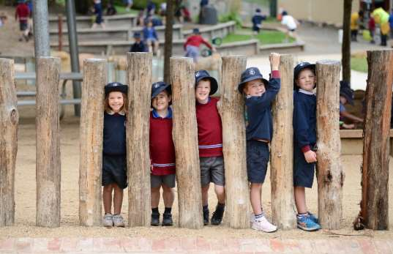


Our School Mission
Our School Vision
Called to action through Gospel values and Mercy tradition we will enrich thinking, expand horizons and pursue excellence!

Through our ardent and all-encompassing Mercy work at St Francis Xavier Primary School, we will engender a passion for learning, respect and an ability to live in harmony with
God’s creation.

Charged with the ministry of our vision statement we are committed to the following core values:

1. Respect 2. Compassion 3. Excellence 4. Justice 5. Hospitality

“Mercy not only bestows benefits, but receives and pardons again and again.” Catherine McAuley

Central to the mission of St. Francis Xavier Primary School is an unequivocal commitment to fostering the dignity, self-esteem and integrity of children and young people and providing them with a safe, supportive and enriching environment to develop spiritually, physically, intellectually, emotionally and socially.

Our School Prayer
Loving God,
Our school has a history Help us to honour that history, to implement our vision, and to live out our call.

Guide us to make real the tenderness of Jesus, the courage of Catherine McAuley,
the missionary vision of St Francis Xavier, and the dreams of those who have gone before us.

Help us gather the young, welcome the stranger, and live as Jesus did.
Inspire us to be caring of our earth, just and merciful, to use well the gifts you have given us and to keep alive in us the call to Mercy

We make our prayer through Jesus who shows us the way and in the power of your Holy Spirit.

Amen.

School Overview
Currently St Francis Xavier Primary School operates under the co-governance of Institute of Sisters of Mercy Australia and Papua New Guinea (ISMAPNG) and the Catholic Diocese of Ballarat. It has a rich tradition of providing quality education and care for children from the City of Ballarat and surrounding districts.

St. Francis Xavier Primary School has built a learning environment founded on fundamental values such as love, respect, forgiveness and trust, drawing on the inspiration and example of the Sisters of Mercy.

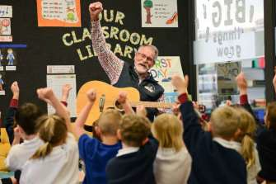
The learning environment at St. Francis Xavier Primary School truly supports the academic growth of all children. Our school offers a quality learning environment, with many specialist areas, including Visual Art, Performing Arts, Technology, Physical Education. A comprehensive Environmental Education program immerses students in their role as custodians of the land on which we live.


St. Francis Xavier Primary School draws on the research and development of the Catholic Education Commission of Victoria. This research and development has been at the forefront of successful developments in Literacy and Numeracy education.

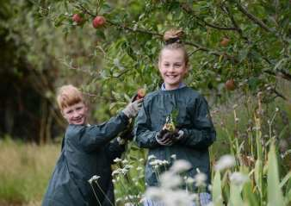
St Francis Xavier Primary School has a current enrolment of 484 children operating as 22 class groups. Attendance records for all students are kept and on average, student attendance rate for 2024 was 94%

It is the policy of St. Francis Xavier Primary School that children’s learning is the core that drives the choices made when structuring authentic learning experiences for them. Learning and teaching will occur in an atmosphere that promotes spirituality, moral confidence, ethics and emotional intelligence in the relationships between students, staff and parents. This will be built on relationships that support and challenge all members of the Learning Community.

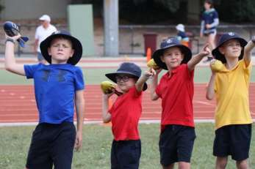
Children have the opportunity to take responsibility for their learning, and to utilise appropriate learning technologies to support their learning. Parents are valued as active participants in the education process.

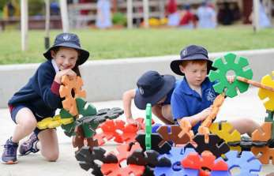
Each class at St. Francis Xavier Primary School works proactively and creatively to deal with the management of student behaviour. A range of support services from the Catholic Education Office and local agencies are accessed to support the physical, social, emotional and academic needs of children.

St. Francis Xavier Primary School is a caring community made up on people from a range of family, social and religious backgrounds. This caring community positively acts to serve the needs of each family.

St. Francis Xavier Primary School structures fees and levies to ensure that the maximum benefit is gained for each child from every dollar spent.

A whole staff approach to dealing with school issues ensures that every effort is made for each child to enjoy success as they grow and develop within our supportive school community.

History of Our School
In 1881 the Sisters arrived in Ballarat, led by Agnes Graham. In addition to their work in education, they are committed to social justice, health care, and working with the poor and marginalised in our world. They continue Catherine’s work with today’s refugees and asylum seekers, with women, with youth, and with the homeless.

In 1902, the Sisters of Mercy, Ballarat East purchased 'Fortune's Folly' and the grounds at Mt. Xavier.

This beautiful home and its surroundings were established as the Villa Maria Convent and developed into a small farm to supply primary produce for the community of Sisters and boarders at the nearby Sacred Heart College.

In 1905 alterations to the Convent were approved so that a boys' boarding school could be established for junior boys from Prep to Year 8. Three students were enrolled at this time. The school was formally registered and opened in 1914 as St. Francis Xavier Primary School.

The School grew and flourished, growing to include day students in 1960 and becoming co-educational in 1974. The facility for boarders concluded in 1978 and St. Francis Xavier Primary School has continued as a co-educational primary school for day students until the present time.

Distinctive Features:
St. Francis Xavier Primary School enjoys a position of high regard in the local community. Staff share a belief in the dignity of individuals and the promotion of self-esteem and community responsibility amongst the students. Some distinctive features include:
- Structured Literacy is our evidenced based systematic approach to literacy incorporating reading and writing
- Comprehensive curriculum based on Gospel values and informed by the Victorian Curriculum.
- Opportunities for students to gain extra support for their learning through support programs: MultiLit, MiniLit, MAQLit, JWMMs Maths and Reading Tutor operating within the school.
- A unique Environmental Education program that reflects our links to the charism of the Sisters of Mercy.
- Dedicated, committed and competent staff.
- Strong community links with parents, in order to foster a collaborative partnership in the development of the students’ learning.
- Commitment of staff to professional learning in order to improve their efficacy.
- A family atmosphere, evident amongst staff, students and community members, fosters a sense of belonging to a wider community within the parish and local area.
- Support for the policy development and stewardship of the school by the St. Francis Xavier School Board, in collaboration with the Governors, Principal and staff.
- Parents who are committed to supporting the efforts of staff.
- Warm, bright, attractive and spacious classrooms that are appropriately furnished and provide a stimulating and nurturing learning environment.
- Spacious school grounds, providing ample space for recreational and sporting activities.

Enrolment Process

Thank you for considering St Francis Xavier Primary School for your child’s education.
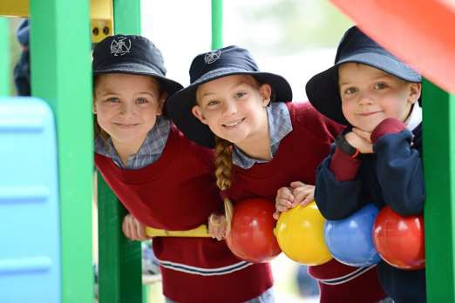

Foundation Application Enrolment Process

This is for families who do NOT currently have older siblings enrolled at a Catholic primary school. If you wish to enrol a younger sibling of a student already at St Francis Xavier Primary School, please contact us directly.

Step 1: Attend an Open Morning ‘School Alive’ Tour Or ‘Virtual Live’ Tour
Please join us on one of the dates held during February and March each year for a School Alive Tour which consists of an information session, followed by a tour of the school and look out a Virtual Live Tour coming soon on our website. Please register your intention to attend any session online at our website www.sfxballarat.catholic.edu.au/enrol/ or phone the school office on 5331 6311.

Step 2: Fill in an ‘Expression of Interest’ with the Catholic Diocese of Ballarat Education Office. The online Expression of Interest is the second step in the enrolment process. Please note that completing the form does not guarantee an enrolment offer. If you wish to do so, please nominate St Francis Xavier Primary School as your first preference for your child’s education. Please fill in and submit the City of Ballarat Catholic School Expression of Interest Form on the Ballarat Catholic Education website https://dobcel.catholic.edu.au/our-schools/enrolments-expression-of-interest-form/

Age
Victorian children are eligible to commence school if they are 5 years of age on 30 April in the year they start school.

Eligibility
The School has set priorities to ensure Catholic children living within the parish have a place available to them in the school. While the priority of the Principal is to enrol the children of Catholic parents, where deemed appropriate, pastoral discretion may be exercised in enrolment.

The order of priority for the school as outlined in the Enrolment Policy and Procedures (DOBCEL) St Francis Xavier Primary School is:

1. Siblings of children already enrolled in the school
2. Catholic children for whom this is the closest Catholic Primary school to the child’s predominant residential address
3. Catholic children for whom this is not the closest Catholic Primary school to the child’s predominant residential address (for pastoral reasons, following referral of parents to the closest school and discussions between colleague Principals)
4. Other children who are seeking a Catholic education with priority given to those for whom this is the closest Catholic Primary School to the child’s predominant residential address.

Key Dates for Foundation Enrolment
Key Dates may vary from year to year, please check our website for Enrolment Closure date deadline and other important dates http://www.sfxballarat.catholic.edu.au/enrol/

Enrolment at year levels other than Foundation

Please contact the school office on 5331 6311 for any enrolment enquiries for year levels other than Foundation. Please download, complete and submit to our school your SFX Enrolment Form and SFX Supplementary Application Enrolment Form.
When children are transferring from another school a Transfer Note is required. Copies of student reports would also be appreciated to help the teacher assess the child and help the child settle in to school life

Please click here for the St. Francis Xavier Primary School – Enrolment Form.
Please click here for the St. Francis Xavier Supplementary Application Enrolment Form.

Any questions regarding enrolments please contact the school office on 53316311

Curriculum Overview
St. Francis Xavier Primary School understands the importance and value of The Victorian Curriculum as it is a curriculum which provides a single, coherent and comprehensive set of prescribed content and common achievement standards, which schools use to plan student learning programs, assess student progress and report to parents. The Victorian Curriculum assists teachers to understand what is essential for students to achieve from Years Foundation to 10 in Victorian schools.

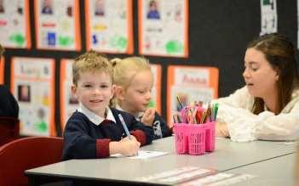
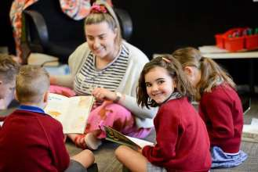

The challenge of schooling in the global knowledge economy of 21st century is to equip students with the knowledge, skills and behaviours to prosper in our modern and ever-changing world.
At St. Francis Xavier Primary School we endeavour to instill in children the skills and confidence to use their talents gifted to them by God and to use these skills to make a difference in their world. At St. Francis Xavier we know that high quality Teaching and Learning comes from the following:

- Explicit Teaching - We can never say “it is enough.”
  - There are high expectations in regard to learning outcomes
  - Children are always clear about expectations and indictors of achievements.
  - We always use data purposefully to drive our teaching and learning.
  - We are consistently improving school based and standardized assessment results.

- Community of lifelong learners - The adage “never too old to learn” is a great comfort to me.
  - The learning environment is engaging and purposeful
  - Students at St. Francis Xavier are active participants in becoming responsible learners.
  - Through and engaging and purposeful learning environments we know student's motivation will increase.
  - Students at St. Francis Xavier see themselves as successful learners
  - Staff are active learners within a high performance development culture
  - Collaboration between staff to improve their own teaching as well as the teaching within the whole school.
  - Staff are committed to personal learning goals and a professional learning plans.
  - Staff are open to constructive feedback.

Guided by Jesus through the face of Mercy - If the love of God really reigns in your heart, it will show itself in the exterior.
  - We will engender a passion for learning, respect and an ability to live in harmony with
God’s creation
  - Charged with the ministry of our vision statement we are committed to the following core values: Mercy, Respect, Compassion, Excellence & Justice

- Positive Relationships - We should be shining lamps, giving light to all around us.
  - We believe in fostering the development of positive relationships through a welcoming, caring and nurturing environment
  - Students are safe, happy and learning
  - Parents feel welcome and informed

Religious Education

Effective learning in Religious Education occurs in a supportive setting which considers and celebrates difference. We encourage listening and dialogue with others as part of our learning process. Catholic teachings are presented as viable options for our students as they form their own identities and grow in the fullness of life. The message of the Gospel is to be shared in a way that engages with modern culture. Our teaching and learning processes are aligned with the Diocese of Ballarat (DOBCEL), utilising the Awakenings Religious Education Curriculum, through the lens of Enhancing Catholic School Identity (ECSI).

The aims of Religious Education
1. Making students receptive to religious questions
2. Becoming aware of the plural voices in society and among the students
3. Giving testimony to and presenting the richness of the Catholic tradition
4. Inviting and supporting students to grow in religious self-understanding

Parents and the Religious Education Program
Religious Education at St. Francis Xavier Primary School will:
- Recognise and respect parents as the first educators of their child in faith;
- Support and encourage them in this role;
- Encourage parents to participate as partners in the education of their children;
- Consult with and accept contributions from parents openly and warmly;
- Recognise the ways in which parents can contribute to the development and implementation of the Religious Education Program;
- Care for parents and their own education in faith in a pastoral way; and
- Provide opportunities for adult education in faith.

Sacraments and Religious Education

St Francis Xavier School falls within the boundary of St Alipius Parish. Sacraments are parish co-ordinated, family-based and school supported.

Students who are baptised as Catholic and wish to receive the sacraments of Confirmation (Year 3), Reconciliation (Year 4), Eucharist (Year 4) will enrol for the preparation program through the parish. Parents and caregivers are required to attend a Parent Information Session prior to enrolment. Classroom units of work in Religious Education will be organised around concepts which complement the sacrament to be received at these grade levels.

Student Wellbeing - Counselling Services
The school has a School Counsellor who works on a part-time basis and can provide access to counselling services upon request.

Child Safety
All students enrolled at St. Francis Xavier Primary School have the right to feel safe and be safe. The wellbeing of children in our care will always be our first priority and we do not and will not tolerate child abuse. We aim to create a child-safe and child-friendly environment where children are free to enjoy life to the full without any concern for their safety. There is particular attention paid to the most vulnerable children, including Aboriginal and Torres Strait Islander children, children from culturally and/or linguistically diverse backgrounds, and children with a disability.

Our commitment to our students
- We commit to the safety and wellbeing of all children and young people enrolled in our school.
- We commit to the safety and wellbeing of all children and young people visiting our school.
- We commit to providing children and young people with positive and nurturing experiences.
- We commit to listening to children and young people and empowering them by taking their views seriously, and addressing any concerns that they raise with us.
- We commit to taking action to ensure that children and young people are protected from abuse or harm.
- We commit to teaching children and young people the necessary skills and knowledge to understand and maintain their personal safety and wellbeing.
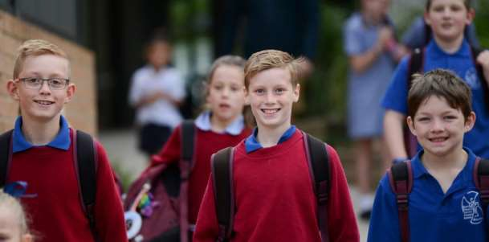
- We commit to seeking input and feedback from students regarding the creation of a safe school environment.

Whilst St. Francis Xavier Primary School is compliant with the Child Safety requirements Child Safety is an ongoing commitment and our school will continually monitor, review and evaluate our policies and practices to maintain the requirements in regard to awareness, understanding and organisational preventative measures to ensure the safety of the students at St. Francis Xavier Primary School.

Our staff are committed to understanding and accepting the associated policies and Code of Conduct and Catholic Professional Standards which gives clarity and clear direction for Child Safety.

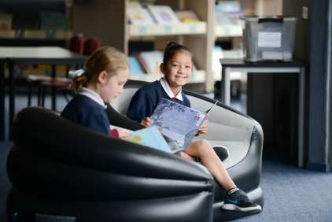

Other Child Safety documents at our school include the following policies which are available on our website

www.sfxballarat.catholic.edu.au

For further information in regard to child safety from the Catholic Education Ballarat go to the following website - http://www.ceoballarat.catholic.edu.au/child-protection/ or from the Victorian Registration and Qualification Authority please go to http://www.vrqa.vic.gov.au/childsafe/Pages/default.html

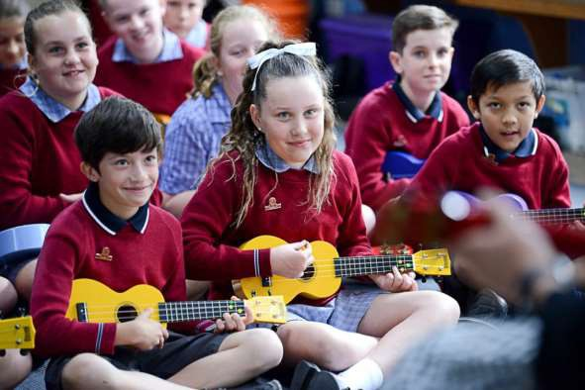

Parental Involvement

Classroom Helper Program

We welcome and value parental support for excursions or special activities throughout the year.
All Classroom Helpers are required to have a current Working with Children Check and to have read, signed and understood the Safeguarding Children and Young People Code of Conduct.

Governance
The School Advisory Council consists of St. Francis Xavier Community Representatives and members of school leadership . The School Advisory Council meets at least six times a year and act as an advisory forum on matters pertaining to the life of the school. It is expected that School Advisory Council members promote the Catholic Ethos of the school and support the development and promotion of school community.
The following are some ways the School Advisory Council supports the school and the principal:
  - provide a voice for members of the school community
  - actively support, in collaboration with the local parish, the Vision and Catholic Identity of the school
  - provide input into and support for strategic planning and directions
  - actively support and promote child safety practices including the National Safeguarding Principles for Child Safe Organisations
  - provide input and contribute advice in the processes of school improvement and school review
  - support the Principal in meeting his/her responsibilities and accountabilities for educational outcomes, effective stewardship of resources, and annual reporting
  - actively support the Principal in the encouragement of family engagement
  - support the ongoing sustainability of the SAC and its members in its succession and learning

Parent and Friends Committee

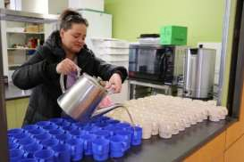


The Parents’ and Friends’ Committee plays an important role with fundraising and social activities within the school. The financial assistance provided by the Parents’ and Friends’ Committee has benefited the school in many ways, e.g. purchasing classroom resources, computers, audio visual and playground equipment.

The Committee has the following major goals:
a) To support the school staff in ensuring a quality education for our children through its interest and participation in activities and programs of the school.
b) To be the social body of contact for new parents within the school so that they may fit comfortably into our community.
- To raise funds to supply the school with quality educational aids and equipment.
- To act as a sounding board for discussion on school policies and Catholic Education policies which affect our school and our children.

School Finances
Understanding the complexities of the funding of a Catholic school is often confusing. In particular, the relationship between Government Grants, school fees and income from fundraising is better understood when explained more fully.

Basically, a Catholic school’s income is derived from three sources:

Government Grants (both Commonwealth & State):
These cover such areas as salaries, superannuation, Work Cover, interest on capital debts and Catholic Education Office levies.

Local Contribution:
This is made up of school fees, interest and donations, i.e., Parent Club fundraising. It is an expectation of Governments that, in order to qualify for Government funds, school communities must contribute financially to their parish school, and thus ensure that a satisfactory standard is maintained, both in the education of the pupils and also in the administration and maintenance of the school.

- Classroom Income: This is made up of –
  - Government Grants (both Commonwealth & State). These grants are used to provide materials used by the children in the classroom.
  - Student Fee. These are charged at the beginning of each year.

Family Fee Assistance Scheme
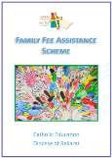

In 2011 the Ballarat Diocese introduced the Family Fee Assistance Scheme. The scheme offers a family fee discount to those families who hold a health care card, please find the application form on our website.

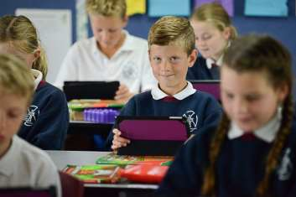
School Fees and Levies
School Fees and Levies are set at the end of each school year for the following twelve month period. Detailed information and a payment plan sheet will be available in Term 4 for the following school year. Payment options available are Direct Debit, eftpos, cash or cheque.

Parents who experience difficulty in meeting their school fees are asked to make an appointment with the principal when the matter will be discussed in total confidence.

Please find below the fee schedule for 2025 as ratified by the School Board. Also below is an extract from the St. Francis Xavier Primary School, School Fee Collection Process, as ratified by the School Board and the Finance Committee. “It is the expectation of the school that, at a minimum, a payment equal to the amount of one term’s school fees, is paid by the end of each school term.”

Capital Fee: $570 per family
Tuition Fee: (1 child family) $1,420 p.a.
Tuition Fee: (2 or more children) $2,360 p.a.
Student Fee: $490 per child Foundation to Year 6
ICT Levy: $120 per child
Swimming Fee (Yrs 1-6): $65 per child

The following is a breakdown of the areas the Annual Student Fee will be utilised.
- Student Requisites/Stationery & Materials
- Religious Education Resources
- Numeracy
- Literacy
- Information and Technology
- Numeracy Resources
- LOTE
- Intervention Programs
- Integrated Curriculum
- Environmental Education/Kitchen Garden
- Student Wellbeing
- Library/Resource Centre Resources
- Art/Craft
- Music
- Physical Education

School Camps: | Foundation | $ 55
 | Year One | $ 55
 | Year Two | $ 85
 | Year Three | $115
 | Year Four | $260
 | Year Five | $380
 | Year Six | $380

General Information

School Routines

School commences at 8.56am and finishes at 3.15pm. Yard supervision commences at 8.30am. Families who need to drop children off earlier than 8.45am are asked to first discuss this with the Principal. Due to the lack of direct supervision we do not encourage early arrives. All children are required to wait in the undercover area until 8.45am. Classrooms are opened for students at 8.30am.

Students will be supervised in the Undercover area until 3.15pm. Students who have not been picked up by 3.40pm will be asked to wait in the school office.

School Newsletter

Our Newsletter is published every Monday and sent to families by email. It is also available on the school website -www.sfxballarat.catholic.edu.au/ news-events/school-calendar/ Hardcopies of the Newsletter are available in the Office.

School Facebook



DID YOU KNOW that St. Francis Xavier Primary School, Ballarat East has a Facebook Page! Invite your friends and "LIKE" us on Facebook to keep up to date with social events and things happening around the school and reminisce as we go through the archives!

Please note this site will be moderated and untoward comments will be censored.

We encourage people to use the site to keep abreast of school events as photos are updated regularly!
https://www.facebook.com/pages/St-Francis-Xavier-Primary-School/273229632859103

Contact Details

ADDRESS | 100 Fortune Street, Ballarat East. Victoria 3350
POSTAL ADDRESS | PO Box 2027, Ballarat Mail Centre, Victoria 3354
PRINCIPAL | Mr. Mark Hogbin
GOVERNING AUTHORITY | DOBCEL- Diocese Of Ballarat Catholic Education Limited
TELEPHONE | (03) 5331 6311
FAX | (03) 5331 8337
OFFICE HOURS | 8:30am to 4:30pm
EMAIL  WEBSITE | principal@sfxballarat.catholic.edu.au  www.sfxballarat.catholic.edu.au

